Catholic Children’s Society

Staff Mental Health Policy

Mental health problems are believed to be experienced by one in six adults, with mental health concerns being the second most prevalent reason for employee absence. This policy uses the term ‘mental health problem’ to include signs of stress and anxiety, and mental health conditions that have been diagnosed by a medical professional, such as depression or PTSD.

CCS understands the positive impact that healthy and engaged employees make to the success of the business. As such, CCS pledges to provide initial, and ongoing, support and help for employees going through mental health problems. The purpose of this policy is to assist with creating an open and honest workplace where line managers and employees can discuss mental health problems, and to ensure the necessary support is known and offered to employees when needed.

Legal obligations

CCS understands the role it has in ensuring that health and safety legislation is adhered to. CCS undertakes to create a safe workplace where risks to mental health and wellbeing are limited as far as possible. Additionally, CCS understands the protection employees with a disability have against discrimination under the Equality Act 2010, including the obligation for employers to introduce reasonable adjustments for disabled employees.

Recruitment

Unless it is related to the specific requirements of the job, CCS will not ask applicants at any stage of the recruitment process for information regarding any previous health issues, in order to ensure potential employees are not discriminated against because of their mental health history.

Indicators

To prevent mental health problems escalating, early intervention is important. In many cases, obvious indicators that an employee is suffering from a mental health problem may not be present, however, early signs can include:

- Behavioural, mood or temperament changes, especially when communicating with others.
- Decrease in productivity and focus.
- Inability to make decisions and problem solving.
- Showing signs of tiredness or being withdrawn and unable to take part in hobbies they usually participate in
- Reducing intake of food or increasing intake of alcohol, cigarettes etc.

Line manager responsibilities

When dealing with an employee with mental health concerns, line managers should be open, welcoming and friendly. They should invite the employee to regular private meetings and ask them to talk openly about their mental health problems. The line manager should not make presumptions about how the mental health problem is impacting on the employee personally and professionally. Initial action should be to check how the employee is getting on at work, in the same manner as if the employee was suffering from a known physical health problem.

Employee responsibilities

Any support required by the employee is likely to be known by the employee themselves. CCS actively encourages employees to be open and honest about their mental health and to inform their line manager of any issues at an early opportunity to allow these to be addressed. There is also an expectation on all CCS employees to conduct themselves in a helpful and open-minded manner towards colleagues who have mental health problems.

Action planning

Mind (a mental health charity) recommends that, where a line manager identifies a mental health issue, they should work alongside the employee to create a personal wellness action plan that provides for proactive management of their mental health. This will support ongoing open communication between line managers and employees and will result in mutually agreed steps being set in place that can be monitored on an ongoing basis.

A wellness action plan should cover:

- Actions and measures that can support the employee’s mental health.
- Symptoms and triggers for poor mental health.
- The impact mental health problems have, or could have, on the employee’s performances.
- Any workplace supported required from their line manager or colleagues.
- Any positive actions the employee can take when suffering from poor mental health.
- A review process to ensure the workplace support is having the required effect.

To ensure the plan meets the employee’s requirements, it should be drafted collaboratively by the employee themselves and their line manager, with medical advice being sought where necessary. Any information in the plan, and the plan itself, should be kept confidential and reviewed on an ongoing basis by both the employee and their line manager.

Workplace adjustments

The Equality Act 2010 defines a disability as “a mental or physical impairment that has a substantial long-term adverse effect on an individual’s ability to carry out normal day-to-day activities”. CCS is legally obliged to make reasonable adjustments to an employee’s role or workplace if they have a disability that places them at a disadvantage when performing their role. CCS will endeavour to consider all reasonable workplace adjustments for any employee who is suffering from a mental health issue.

Examples of adjustments include:

- Adjusting hours of work or the location of work, including within the building itself.
- Adjusting or reallocating duties of the job role.
- Making amendments to the workplace environment, for example adjusting lighting in the employee’s office.
- Amending absence triggers before disciplinary action is triggered.

Once the adjustments are agreed, they will be reviewed on an ongoing basis to ensure they are having the required effect.

Managing absence and return to work

Where the employee is absent by reason of their mental health concerns, their line manager will communicate with the employee on a regular basis during their absence. The employee returning to work may help with their recovery, so early intervention and support from CCS is important. CCS’s sickness absence policy will apply to the employee’s absence as normal, subject to any reasonable adjustments in place for the employee.

Upon the employee’s return from absence, a return-to-work plan will be discussed and agreed between the line manager and the employee to ensure necessary steps can be taken to support the employee to remain in work. This can include introducing a temporary return on amended working hours, removing stressful duties during a phased return, and providing additional workplace support as necessary.

Confidentiality

Information concerning an employee’s mental health is classed as a special category of personal data. This information will only be disclosed to others in line with CCS’s policies on data protection.

Reviewed: September 2022
Review date: September 2023

Appendix A: Staff support wheel

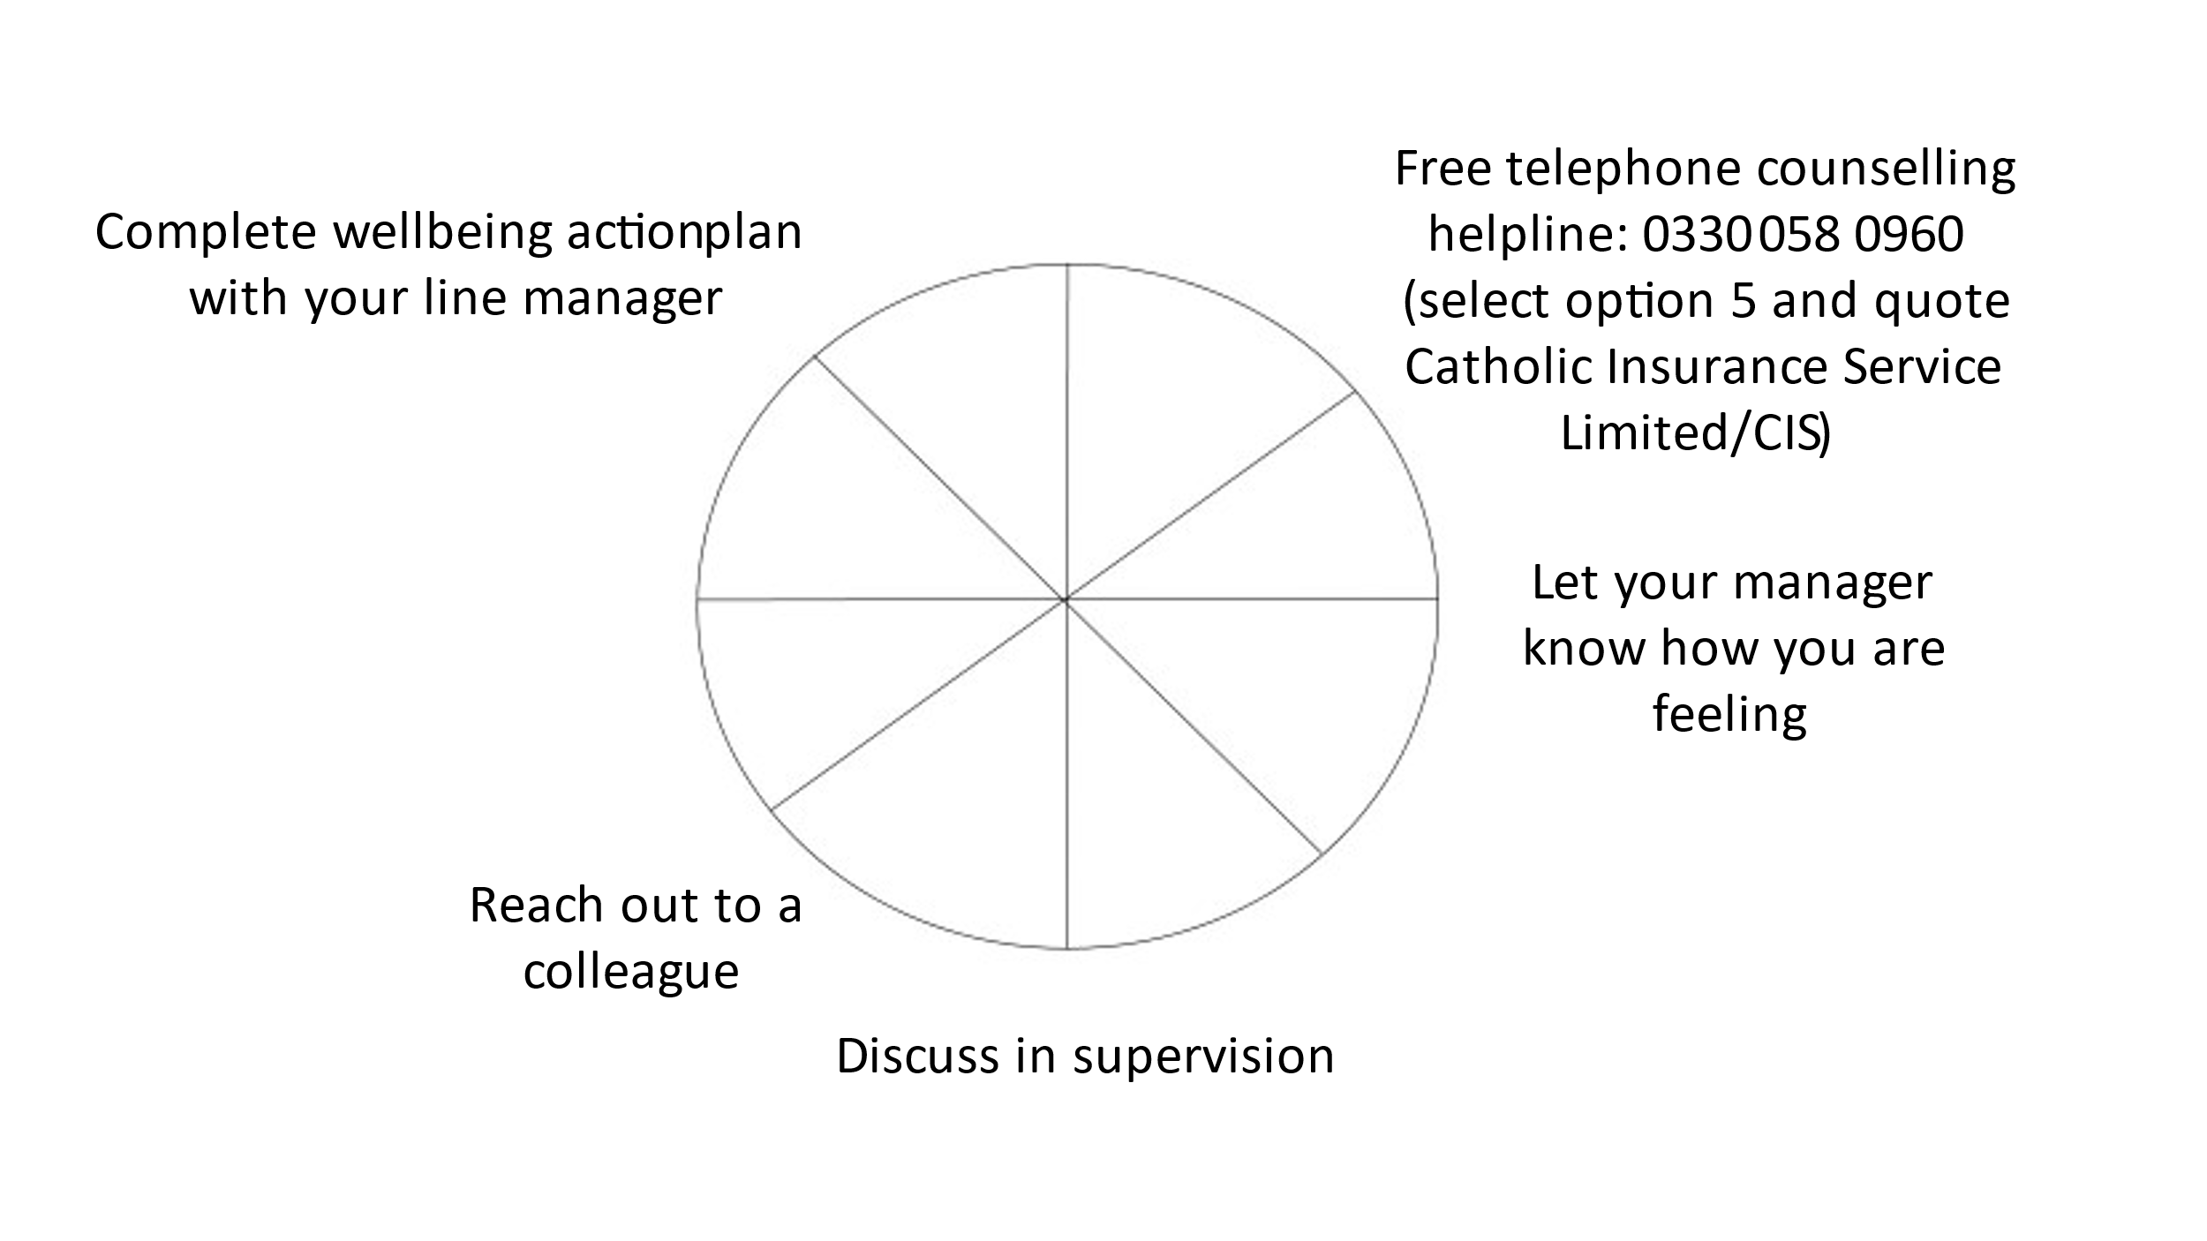

Appendix B: Wellness Action Pan

Employee name:
Manager name:
Date of plan:
Wellness action plan
Identify the employee’s common symptoms of poor mental health
Identify any causes of poor mental health
Consider both work-related and personal factors

Identify each workplace factor which is affected by poor mental health | What workplace measures can be put in place? | What workplace support is available? | What proactive steps can the employee take? | Review date | Have the measures, support or steps reduced the effect of mental health? (Y/N)
Identify any appropriate additional steps which can be taken
Date of next review meeting:

Manager Signed:
Date:
Employee Signed:
Date:

