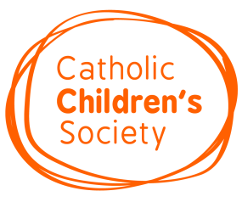

Lenten Appeal 2020 Participation Form

Please complete this form and return by email to kimberleyt@cathchild.org.uk or by post to The Catholic Children’s Society, 73 St Charles Square, London W10 6EJ before Friday 8th November 2019
We would like to support the Catholic Children’s Society during Lent 2020
ORDER
Please indicate how many materials you require:
(one per family, one per child or one per class)
Number of collecting boxes: _________
(one per child)
Number of activity sheets: _________
Staff Member Name

Position

School Name and Address

Telephone Number

Email Address (to receive links for teaching resources)

PRESENTATION
We wish to book a presentation by a representative from the Catholic Children’s Society
Please state 3 preferred dates and times between Monday 13th January and Friday 3rd April. We would be very grateful if one of your chosen dates could include an afternoon/ day other than Monday if possible.
 | Date | Time
1st Choice
2nd Choice
3rd Choice

We will do our very best to allocate your preferred date and time.
Signed: ____________________________ Dated: ____________________

