5 Ways to Wellbeing
- Connected
- Be Active
- Be Curious
- Keep Learning
- Give

Secondary: Notes for Teachers

1 Connected
Activity 1: My Community | Instructions on PPT slide 13.
Activity 2: Charades | Instructions on PPT slide 14.
Activity 3: Reconnect at home | Activity to be completed at home. Instructions on PPT slide 15.
2 Be Active
Activity 1: “It’s ok not to be ok” | As a class, watch the linked video PPT slide 17 YouTube What top athletes have to say about mental health in sport  Start a class discussion - Why do you think it is important that these athletes talk about their mental health?
Activity 2: Small things | Instructions on PPT slides 18-19.
Activity 3: Classroom Yoga | As a class, watch the video of Sophie teaching yoga on PPT slide 20.
Activity 4: Be active at home | Activity to be completed at home. Instructions on PPT slide 21.
3 Be Curious
Activity 1: Be curious about yourself | Square Breathing and Body Scan  Play video on PPT slide 23. This simple exercise helps people to be more aware of their bodies and helps them find a way to be present in the moment. Please be aware that for some people, paying attention to their bodies may be difficult or uncomfortable. Allow young people the option to stop engaging in the exercise if they prefer.
Activity 2: Be curious about your surroundings | The goal of this exercise is to practice being aware and curious in the present moment throughout the day.  Animations on PPT slide 24 can help you to lead the exercise.
Activity 3: Be curious about others | Colouring pencils/pens and a sheet of paper are required for this activity.  Instructions on PPT slide 25.
Activity 4: Be curious at home | Activity to be completed at home. Instructions on PPT slide 26.
4 Keep Learning
Activity 1: Truth or Lie | Instructions on PPT slide 28.
Activity 2: Learning Tree | Learning Tree template activity sheet (available on p.3 of this document) or pupils can draw their own tree. Instructions on PPT slides 29-30.
Activity 3: Keep learning at home | Activity to be completed at home. Instructions on PPT slide 31.
5 Give
Activity 1: Thankful Tree | Equipment: A large cardboard cut-out of a tree trunk with branches (template available here), coloured paper/card, scissors, pens/pencils. Instructions on PPT slide 33.
Activity 2: Kindness Bingo | Bingo activity sheets required for all pupils (activity sheet on p.4 of this document). Instructions on PPT slide 34.
Activity 3: Give at home | Activity to be completed at home. Instructions on PPT slide 35.

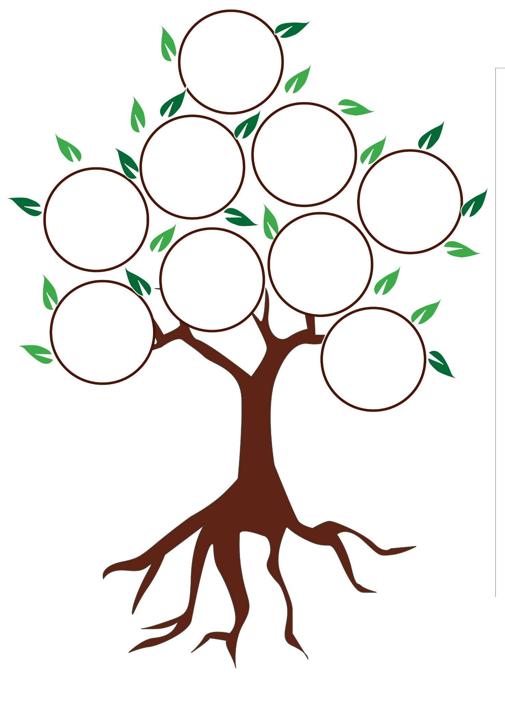
- What do I need to get ready?
- What message will support me along the way?
- What will the benefits be?

